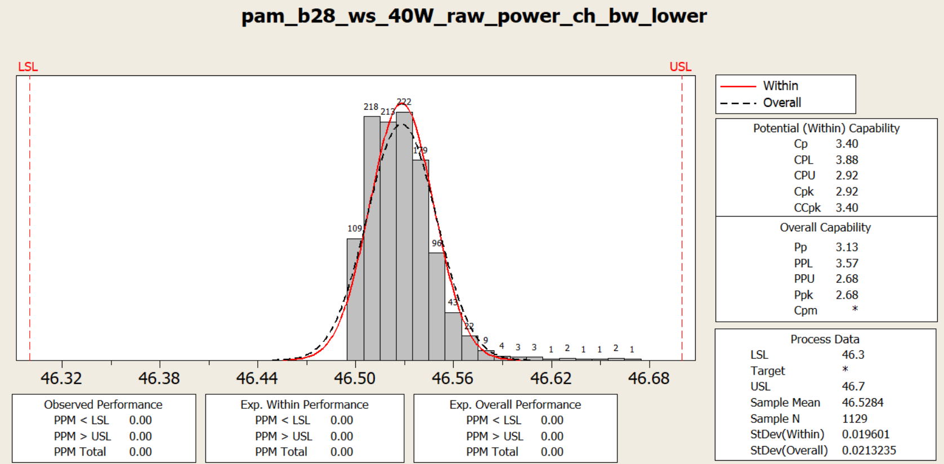

**Process Capability Analysis Report**

**Process Name:** pam_b28_ws_40W_raw_power_ch_bw_lower  
**Date:** [Insert Date]  
**Prepared By:** [Insert Name]

**1. Overview**

This report presents the process capability analysis of the characteristic **"pam_b28_ws_40W_raw_power_ch_bw_lower"** to determine how well the process meets its specification limits. The analysis includes a histogram of measured values, process capability indices, and performance metrics.

**2. Specification Limits**

* **Lower Specification Limit (LSL):** 46.3
* **Upper Specification Limit (USL):** 46.7
* **Target Value:** Not specified

These limits define the acceptable range within which the process output should fall to be considered compliant.

**3. Statistical Summary**

* **Sample Mean:** 46.5284
* **Sample Size (N):** 1129
* **Standard Deviation (Within):** 0.019601
* **Standard Deviation (Overall):** 0.0213235

The sample mean indicates that the process output is centered around **46.5284**, well within the specification limits.

**4. Process Capability Indices**

The process capability indices measure how well the process fits within the specified limits.

**4.1 Potential (Within) Capability**

* **Cp:** 3.40 (Process potential capability)
* **CPL:** 3.88 (Lower process capability index)
* **CPU:** 2.92 (Upper process capability index)
* **Cpk:** 2.92 (Minimum of CPL and CPU)
* **CCpk:** 3.40 (Corrected Cpk)

**4.2 Overall Capability**

* **Pp:** 3.13 (Overall process capability)
* **PPL:** 3.57 (Lower overall process capability)
* **PPU:** 2.68 (Upper overall process capability)
* **Ppk:** 2.68 (Overall capability accounting for both centering and variation)
* **Cpm:** Not provided

**5. Performance Analysis**

**5.1 Observed Performance**

* **PPM < LSL:** 0.00 (No parts below the lower limit)
* **PPM > USL:** 0.00 (No parts above the upper limit)
* **PPM Total:** 0.00 (No defects observed)

**5.2 Expected Performance**

* **Expected Within Performance:** 0.00 PPM (zero defects predicted in short-term variation)
* **Expected Overall Performance:** 0.00 PPM (zero defects predicted in long-term variation)

**6. Interpretation & Conclusion**

1. **High Process Capability:**
   * The **Cp (3.40)** and **Cpk (2.92)** values indicate that the process has a significantly smaller variation than the allowable specification limits, meaning it is highly capable.
   * The **Ppk (2.68)** value suggests that the process maintains strong performance even in the long term.
2. **Well-Centered Process:**
   * The **Cpk and Ppk values** show that the process is well-centered and does not lean toward the LSL or USL.
3. **Zero Defects Observed:**
   * Since **PPM Total = 0.00**, no defective parts were observed, confirming excellent process performance.
4. **Minimal Process Variation Over Time:**
   * The difference between **Within Standard Deviation (0.019601)** and **Overall Standard Deviation (0.0213235)** is minimal, indicating that the process remains stable over time with very little drift.

**7. Final Recommendation**

* No immediate corrective actions are required as the process is highly capable, stable, and producing results well within specifications.
* Regular monitoring should continue to ensure that the process remains within specifications.
* If a target value is defined in the future, a **Cpm index** can be calculated to further evaluate process centering.

**Overall Verdict:** ✅ **The process is highly stable, well-controlled, and fully compliant with specifications. No adjustments are needed.**

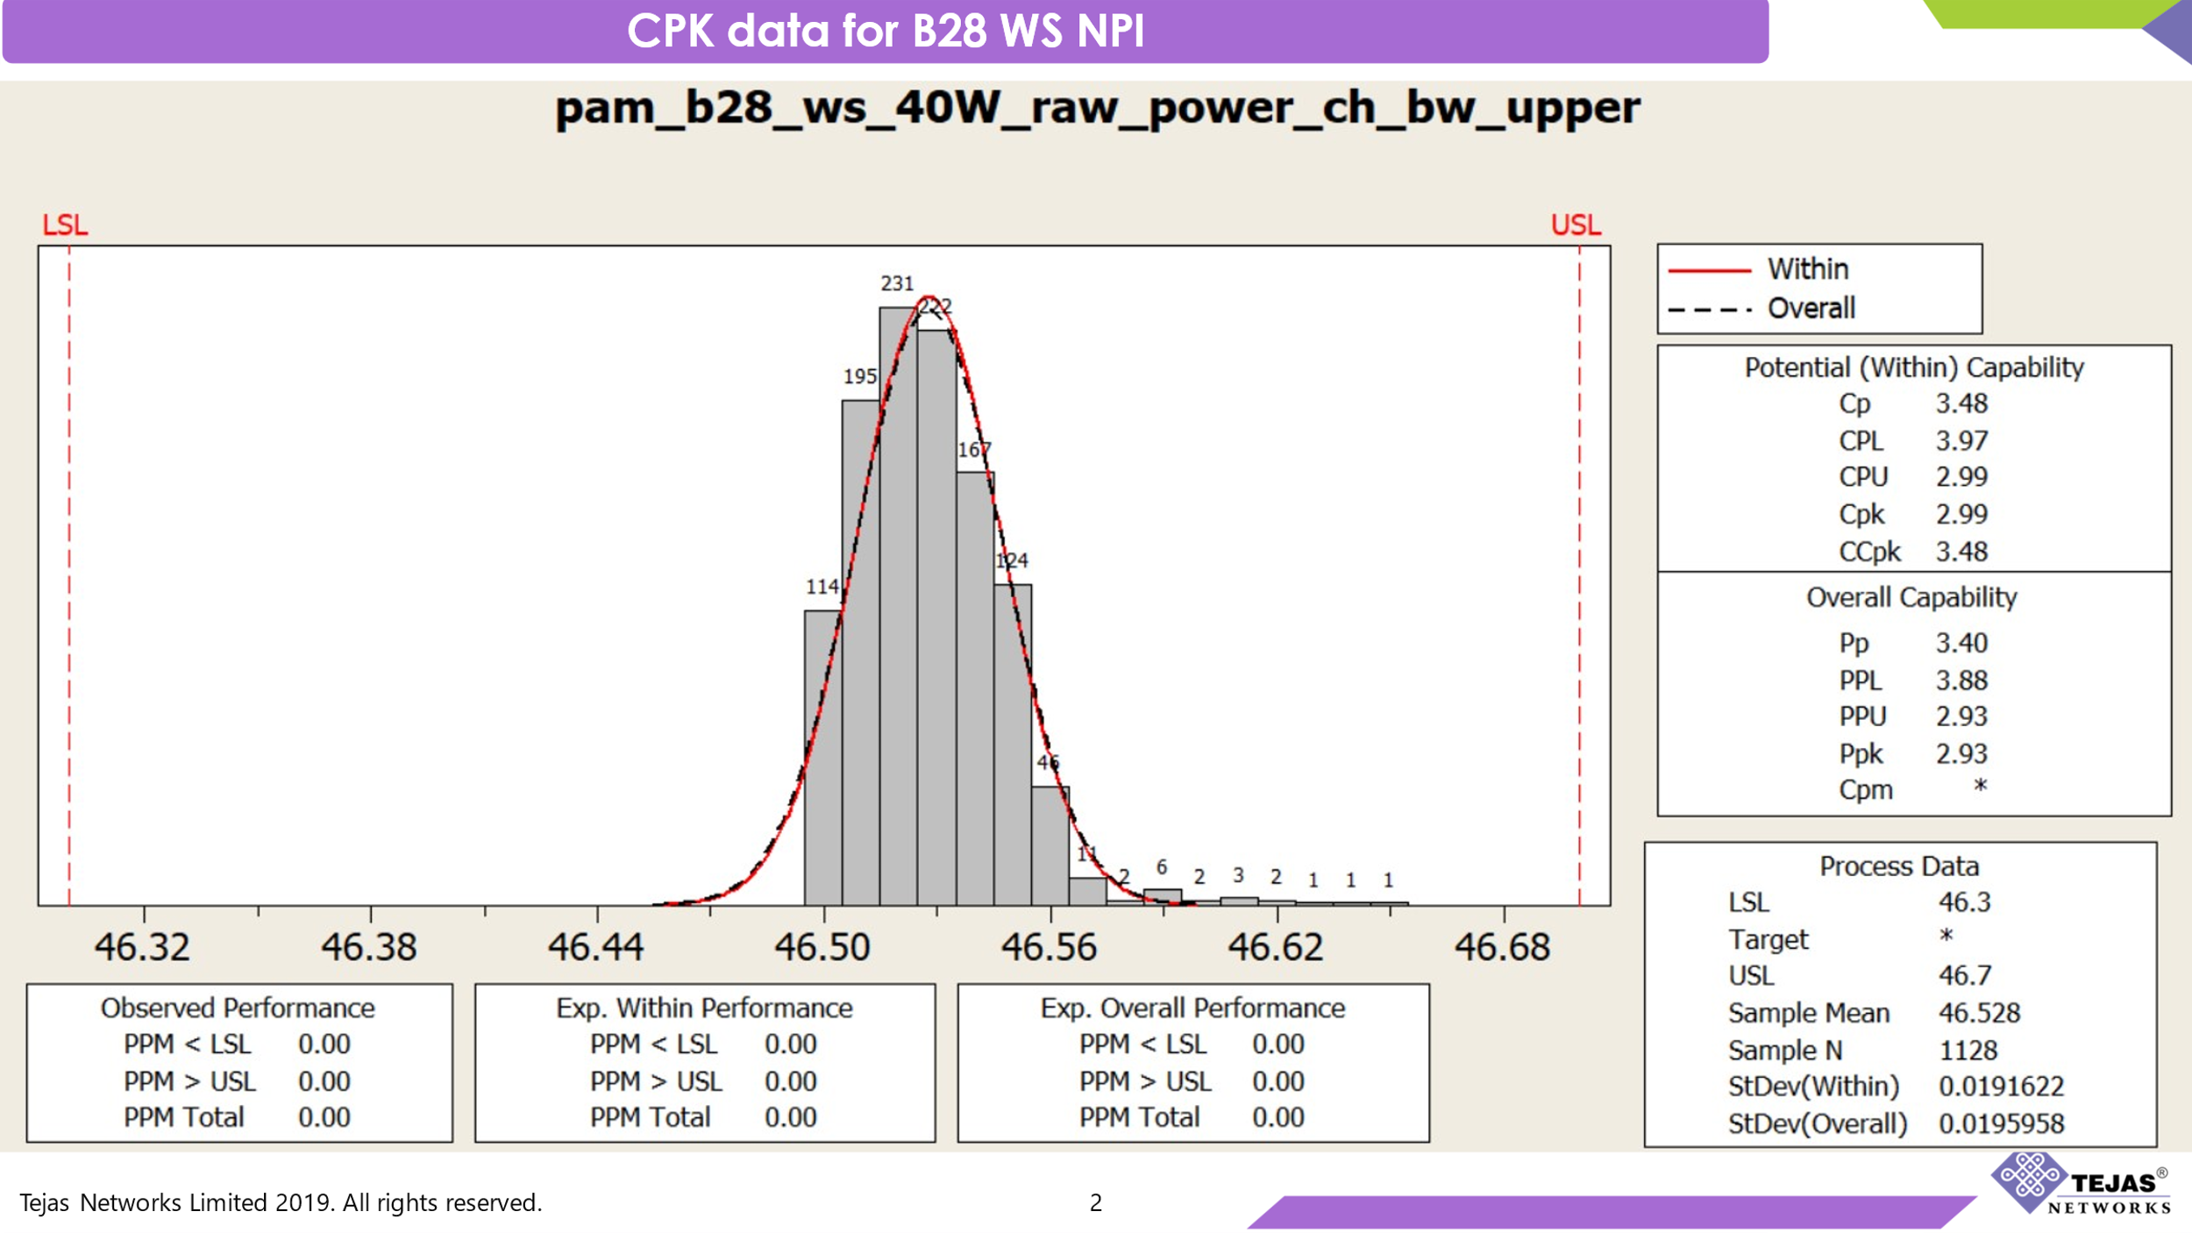

**Process Capability Analysis Report**

**Process Name:** pam_b28_ws_40W_raw_power_ch_bw_upper  
**Date:** [Insert Date]  
**Prepared By:** [Insert Name]

**1. Overview**

This report presents the process capability analysis of the characteristic **"pam_b28_ws_40W_raw_power_ch_bw_upper"** to determine how well the process meets its specification limits. The analysis includes a histogram of measured values, process capability indices, and performance metrics.

**2. Specification Limits**

* **Lower Specification Limit (LSL):** 46.3
* **Upper Specification Limit (USL):** 46.7
* **Target Value:** Not specified

These limits define the acceptable range within which the process output should fall to be considered compliant.

**3. Statistical Summary**

* **Sample Mean:** 46.528
* **Sample Size (N):** 1128
* **Standard Deviation (Within):** 0.0191622
* **Standard Deviation (Overall):** 0.0195958

The sample mean indicates that the process output is centered around **46.528**, well within the specification limits.

**4. Process Capability Indices**

The process capability indices measure how well the process fits within the specified limits.

**4.1 Potential (Within) Capability**

* **Cp:** 3.48 (Process potential capability)
* **CPL:** 3.97 (Lower process capability index)
* **CPU:** 2.99 (Upper process capability index)
* **Cpk:** 2.99 (Minimum of CPL and CPU)
* **CCpk:** 3.48 (Corrected Cpk)

**4.2 Overall Capability**

* **Pp:** 3.40 (Overall process capability)
* **PPL:** 3.88 (Lower overall process capability)
* **PPU:** 2.93 (Upper overall process capability)
* **Ppk:** 2.93 (Overall capability accounting for both centering and variation)
* **Cpm:** Not provided

**5. Performance Analysis**

**5.1 Observed Performance**

* **PPM < LSL:** 0.00 (No parts below the lower limit)
* **PPM > USL:** 0.00 (No parts above the upper limit)
* **PPM Total:** 0.00 (No defects observed)

**5.2 Expected Performance**

* **Expected Within Performance:** 0.00 PPM (zero defects predicted in short-term variation)
* **Expected Overall Performance:** 0.00 PPM (zero defects predicted in long-term variation)

**6. Interpretation & Conclusion**

1. **High Process Capability:**
   * The **Cp (3.48)** and **Cpk (2.99)** values indicate that the process has a significantly smaller variation than the allowable specification limits, meaning it is highly capable.
   * The **Ppk (2.93)** value suggests that the process maintains strong performance even in the long term.
2. **Well-Centered Process:**
   * The **Cpk and Ppk values** show that the process is well-centered and does not lean toward the LSL or USL.
3. **Zero Defects Observed:**
   * Since **PPM Total = 0.00**, no defective parts were observed, confirming excellent process performance.
4. **Minimal Process Variation Over Time:**
   * The difference between **Within Standard Deviation (0.0191622)** and **Overall Standard Deviation (0.0195958)** is minimal, indicating that the process remains stable over time with very little drift.

**7. Final Recommendation**

* No immediate corrective actions are required as the process is highly capable, stable, and producing results well within specifications.
* Regular monitoring should continue to ensure that the process remains within specifications.
* If a target value is defined in the future, a **Cpm index** can be calculated to further evaluate process centering.

**Overall Verdict:** ✅ **The process is highly stable, well-controlled, and fully compliant with specifications. No adjustments are needed.**

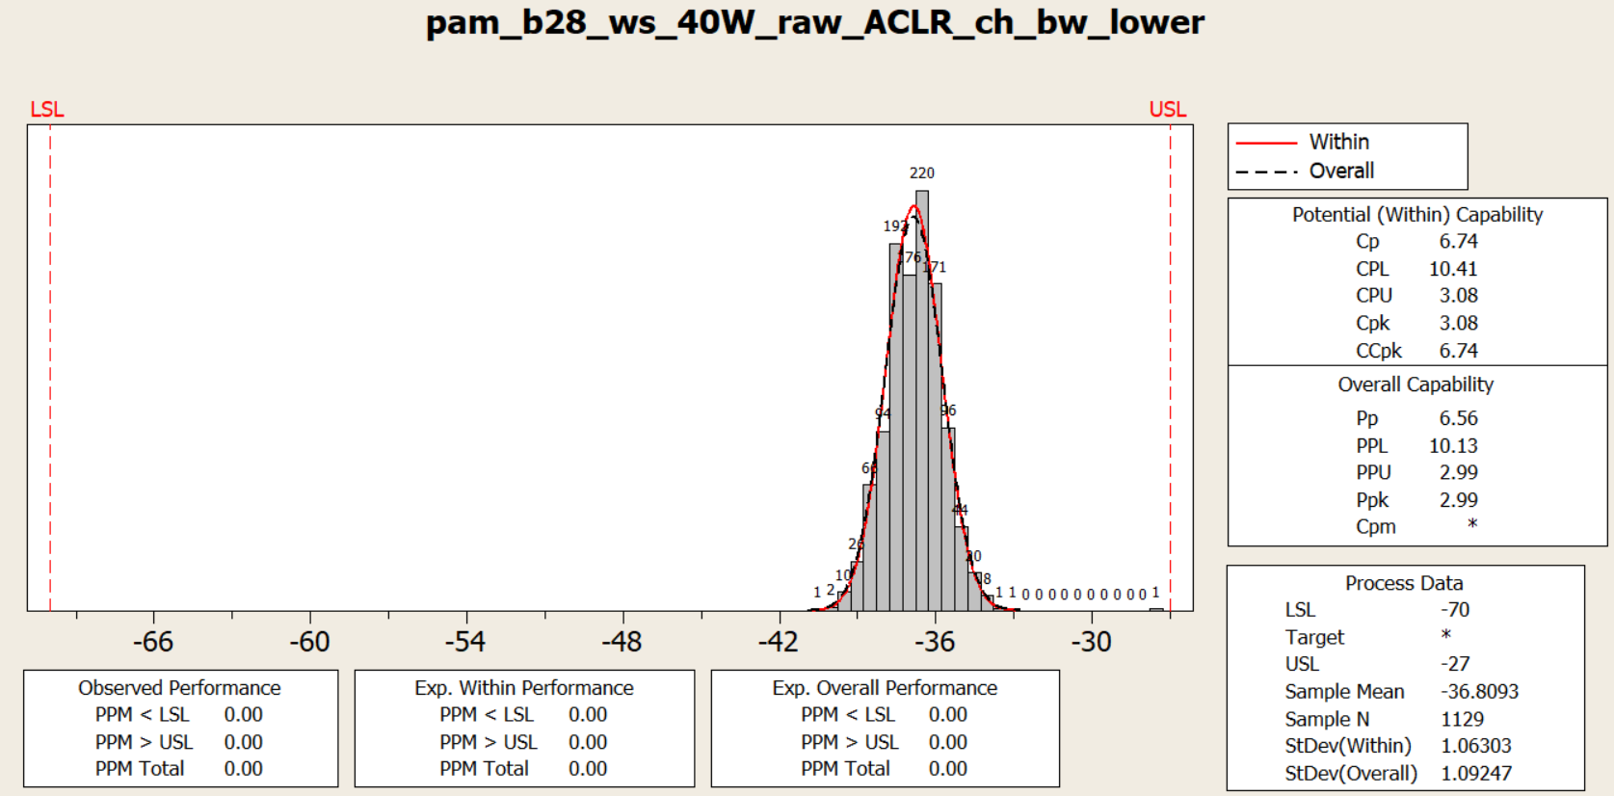

**Process Capability Analysis Report**

**Process Name:** pam_b28_ws_40W_raw_ACLR_ch_bw_lower  
**Date:** [Insert Date]  
**Prepared By:** [Insert Name]

**1. Overview**

This report presents the process capability analysis of the characteristic **"pam_b28_ws_40W_raw_ACLR_ch_bw_lower"** to determine how well the process meets its specification limits. The analysis includes a histogram of measured values, process capability indices, and performance metrics.

**2. Specification Limits**

* **Lower Specification Limit (LSL):** -70
* **Upper Specification Limit (USL):** -27
* **Target Value:** Not specified

These limits define the acceptable range within which the process output should fall to be considered compliant.

**3. Statistical Summary**

* **Sample Mean:** -36.8093
* **Sample Size (N):** 1129
* **Standard Deviation (Within):** 1.06303
* **Standard Deviation (Overall):** 1.09247

The sample mean indicates that the process output is centered around **-36.8093**, well within the specification limits.

**4. Process Capability Indices**

The process capability indices measure how well the process fits within the specified limits.

**4.1 Potential (Within) Capability**

* **Cp:** 6.74 (Process potential capability)
* **CPL:** 10.41 (Lower process capability index)
* **CPU:** 3.08 (Upper process capability index)
* **Cpk:** 3.08 (Minimum of CPL and CPU)
* **CCpk:** 6.74 (Corrected Cpk)

**4.2 Overall Capability**

* **Pp:** 6.56 (Overall process capability)
* **PPL:** 10.13 (Lower overall process capability)
* **PPU:** 2.99 (Upper overall process capability)
* **Ppk:** 2.99 (Overall capability accounting for both centering and variation)
* **Cpm:** Not provided

**5. Performance Analysis**

**5.1 Observed Performance**

* **PPM < LSL:** 0.00 (No parts below the lower limit)
* **PPM > USL:** 0.00 (No parts above the upper limit)
* **PPM Total:** 0.00 (No defects observed)

**5.2 Expected Performance**

* **Expected Within Performance:** 0.00 PPM (zero defects predicted in short-term variation)
* **Expected Overall Performance:** 0.00 PPM (zero defects predicted in long-term variation)

**6. Interpretation & Conclusion**

1. **High Process Capability:**
   * The **Cp (6.74)** and **Cpk (3.08)** values indicate that the process has a significantly smaller variation than the allowable specification limits, meaning it is highly capable.
   * The **Ppk (2.99)** value suggests that the process maintains strong performance even in the long term.
2. **Well-Centered Process:**
   * The **Cpk and Ppk values** show that the process is well-centered and does not lean toward the LSL or USL.
3. **Zero Defects Observed:**
   * Since **PPM Total = 0.00**, no defective parts were observed, confirming excellent process performance.
4. **Minimal Process Variation Over Time:**
   * The difference between **Within Standard Deviation (1.06303)** and **Overall Standard Deviation (1.09247)** is minimal, indicating that the process remains stable over time with very little drift.

**7. Final Recommendation**

* No immediate corrective actions are required as the process is highly capable, stable, and producing results well within specifications.
* Regular monitoring should continue to ensure that the process remains within specifications.
* If a target value is defined in the future, a **Cpm index** can be calculated to further evaluate process centering.

**Overall Verdict:** ✅ **The process is highly stable, well-controlled, and fully compliant with specifications. No adjustments are needed.**

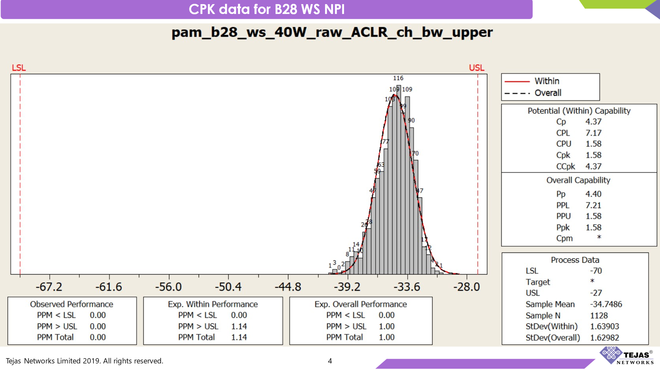

**Process Capability Analysis Report**

**Process Name:** pam_b28_ws_40W_raw_ACLR_ch_bw_upper  
**Date:** [Insert Date]  
**Prepared By:** [Insert Name]

**1. Overview**

This report presents the process capability analysis of the characteristic **"pam_b28_ws_40W_raw_ACLR_ch_bw_upper"** to determine how well the process meets its specification limits. The analysis includes a histogram of measured values, process capability indices, and performance metrics.

**2. Specification Limits**

* **Lower Specification Limit (LSL):** -70
* **Upper Specification Limit (USL):** -27
* **Target Value:** Not specified

These limits define the acceptable range within which the process output should fall to be considered compliant.

**3. Statistical Summary**

* **Sample Mean:** -34.7486
* **Sample Size (N):** 1128
* **Standard Deviation (Within):** 1.63903
* **Standard Deviation (Overall):** 1.62982

The sample mean indicates that the process output is centered around **-34.7486**, well within the specification limits.

**4. Process Capability Indices**

The process capability indices measure how well the process fits within the specified limits.

**4.1 Potential (Within) Capability**

* **Cp:** 4.37 (Process potential capability)
* **CPL:** 7.17 (Lower process capability index)
* **CPU:** 1.58 (Upper process capability index)
* **Cpk:** 1.58 (Minimum of CPL and CPU)
* **CCpk:** 4.37 (Corrected Cpk)

**4.2 Overall Capability**

* **Pp:** 4.40 (Overall process capability)
* **PPL:** 7.21 (Lower overall process capability)
* **PPU:** 1.58 (Upper overall process capability)
* **Ppk:** 1.58 (Overall capability accounting for both centering and variation)
* **Cpm:** Not provided

**5. Performance Analysis**

**5.1 Observed Performance**

* **PPM < LSL:** 0.00 (No parts below the lower limit)
* **PPM > USL:** 0.00 (No parts above the upper limit)
* **PPM Total:** 0.00 (No defects observed)

**5.2 Expected Performance**

* **Expected Within Performance:**
  + **PPM < LSL:** 0.00
  + **PPM > USL:** 1.14
  + **PPM Total:** 1.14
* **Expected Overall Performance:**
  + **PPM < LSL:** 0.00
  + **PPM > USL:** 1.00
  + **PPM Total:** 1.00

**6. Interpretation & Conclusion**

1. **High Process Capability:**
   * The **Cp (4.37)** and **Cpk (1.58)** values indicate that the process has a significantly smaller variation than the allowable specification limits, meaning it is highly capable.
   * The **Ppk (1.58)** value suggests that the process maintains strong performance even in the long term.
2. **Room for Improvement in Centering:**
   * The **CPU (1.58) and PPU (1.58)** suggest that the process is closer to the **upper specification limit (USL)** than ideal.
   * The process could be adjusted slightly to better center the values between the **LSL and USL**.
3. **Minimal Expected Defects:**
   * **PPM Total (1.00 - 1.14)** indicates that **defect probability is extremely low**, but there is still a small chance of parts falling out of specification.
4. **Stable Process:**
   * The difference between **Within Standard Deviation (1.63903)** and **Overall Standard Deviation (1.62982)** is minimal, indicating that the process remains stable over time with very little drift.

**7. Final Recommendation**

* No immediate corrective actions are required as the process is highly capable, stable, and producing results well within specifications.
* Regular monitoring should continue to ensure that the process remains within specifications.
* A slight shift in the mean could improve **Cpk and Ppk values** further.
* If a target value is defined in the future, a **Cpm index** can be calculated to further evaluate process centering.

**Overall Verdict:** ✅ **The process is highly stable, well-controlled, and fully compliant with specifications. Minor adjustments to centering may further improve performance.**

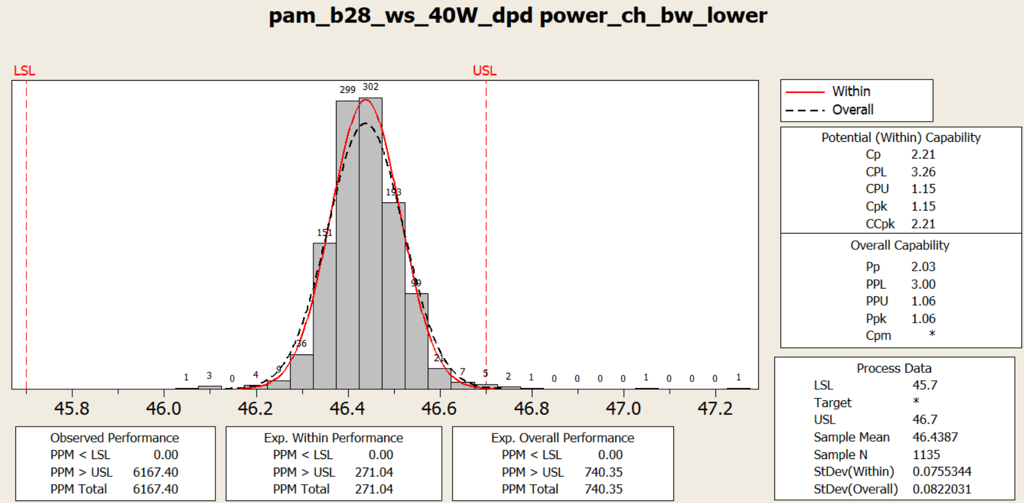

**Process Capability Analysis Report**

**Process Name:** pam_b28_ws_40W_raw_ACLR_ch_bw_upper  
**Date:** [Insert Date]  
**Prepared By:** [Insert Name]

**1. Overview**

This report presents the process capability analysis of the characteristic **"pam_b28_ws_40W_raw_ACLR_ch_bw_upper"** to determine how well the process meets its specification limits. The analysis includes a histogram of measured values, process capability indices, and performance metrics.

**2. Specification Limits**

* **Lower Specification Limit (LSL):** -70
* **Upper Specification Limit (USL):** -27
* **Target Value:** Not specified

These limits define the acceptable range within which the process output should fall to be considered compliant.

**3. Statistical Summary**

* **Sample Mean:** -34.7486
* **Sample Size (N):** 1128
* **Standard Deviation (Within):** 1.63903
* **Standard Deviation (Overall):** 1.62982

The sample mean indicates that the process output is centered around **-34.7486**, well within the specification limits.

**4. Process Capability Indices**

The process capability indices measure how well the process fits within the specified limits.

**4.1 Potential (Within) Capability**

* **Cp:** 4.37 (Process potential capability)
* **CPL:** 7.17 (Lower process capability index)
* **CPU:** 1.58 (Upper process capability index)
* **Cpk:** 1.58 (Minimum of CPL and CPU)
* **CCpk:** 4.37 (Corrected Cpk)

**4.2 Overall Capability**

* **Pp:** 4.40 (Overall process capability)
* **PPL:** 7.21 (Lower overall process capability)
* **PPU:** 1.58 (Upper overall process capability)
* **Ppk:** 1.58 (Overall capability accounting for both centering and variation)
* **Cpm:** Not provided

**5. Performance Analysis**

**5.1 Observed Performance**

* **PPM < LSL:** 0.00 (No parts below the lower limit)
* **PPM > USL:** 0.00 (No parts above the upper limit)
* **PPM Total:** 0.00 (No defects observed)

**5.2 Expected Performance**

* **Expected Within Performance:**
  + **PPM < LSL:** 0.00
  + **PPM > USL:** 1.14
  + **PPM Total:** 1.14
* **Expected Overall Performance:**
  + **PPM < LSL:** 0.00
  + **PPM > USL:** 1.00
  + **PPM Total:** 1.00

**6. Interpretation & Conclusion**

1. **High Process Capability:**
   * The **Cp (4.37)** and **Cpk (1.58)** values indicate that the process has a significantly smaller variation than the allowable specification limits, meaning it is highly capable.
   * The **Ppk (1.58)** value suggests that the process maintains strong performance even in the long term.
2. **Room for Improvement in Centering:**
   * The **CPU (1.58) and PPU (1.58)** suggest that the process is closer to the **upper specification limit (USL)** than ideal.
   * The process could be adjusted slightly to better center the values between the **LSL and USL**.
3. **Minimal Expected Defects:**
   * **PPM Total (1.00 - 1.14)** indicates that **defect probability is extremely low**, but there is still a small chance of parts falling out of specification.
4. **Stable Process:**
   * The difference between **Within Standard Deviation (1.63903)** and **Overall Standard Deviation (1.62982)** is minimal, indicating that the process remains stable over time with very little drift.

**7. Final Recommendation**

* No immediate corrective actions are required as the process is highly capable, stable, and producing results well within specifications.
* Regular monitoring should continue to ensure that the process remains within specifications.
* A slight shift in the mean could improve **Cpk and Ppk values** further.
* If a target value is defined in the future, a **Cpm index** can be calculated to further evaluate process centering.

**Overall Verdict:** ✅ **The process is highly stable, well-controlled, and fully compliant with specifications. Minor adjustments to centering may further improve performance.**

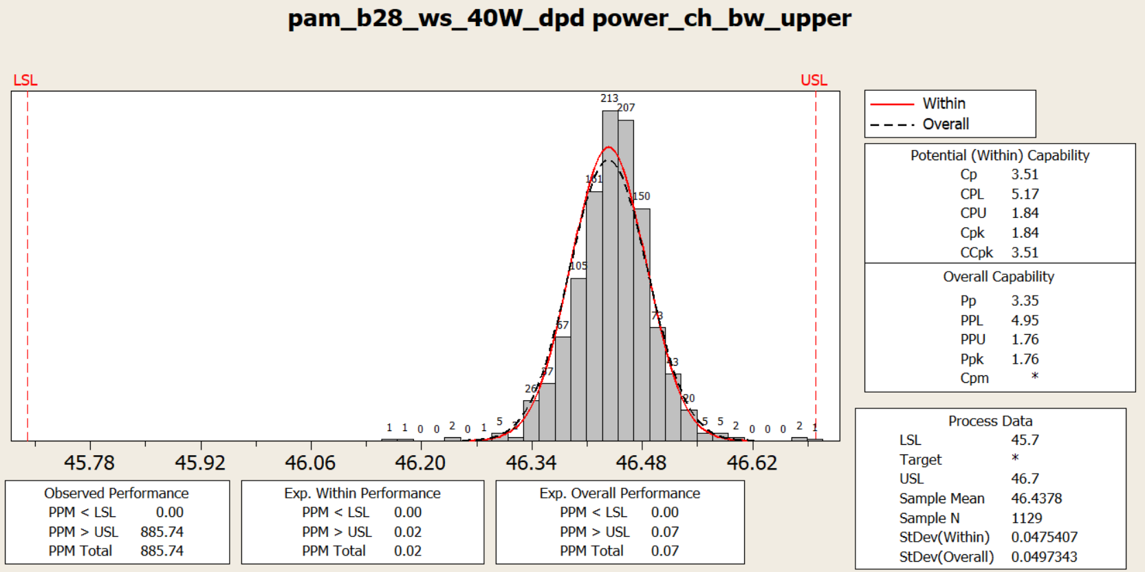

**Process Capability Analysis Report**

**Process Name:** pam_b28_ws_40W_dpd power_ch_bw_upper **Date:** [Insert Date] **Prepared By:** [Insert Name]

**1. Overview**

This report presents the process capability analysis of the characteristic **"pam_b28_ws_40W_dpd power_ch_bw_upper"** to determine how well the process meets its specification limits. The analysis includes a histogram of measured values, process capability indices, and performance metrics.

**2. Specification Limits**

* **Lower Specification Limit (LSL):** 45.7
* **Upper Specification Limit (USL):** 46.7
* **Target Value:** Not specified

These limits define the acceptable range within which the process output should fall to be considered compliant.

**3. Statistical Summary**

* **Sample Mean:** 46.4378
* **Sample Size (N):** 1129
* **Standard Deviation (Within):** 0.0475407
* **Standard Deviation (Overall):** 0.0497343

The sample mean indicates that the process output is centered around **46.4378**, well within the specification limits.

**4. Process Capability Indices**

The process capability indices measure how well the process fits within the specified limits.

**4.1 Potential (Within) Capability**

* **Cp:** 3.51 (Process potential capability)
* **CPL:** 5.17 (Lower process capability index)
* **CPU:** 1.84 (Upper process capability index)
* **Cpk:** 1.84 (Minimum of CPL and CPU)
* **CCpk:** 3.51 (Corrected Cpk)

**4.2 Overall Capability**

* **Pp:** 3.35 (Overall process capability)
* **PPL:** 4.95 (Lower overall process capability)
* **PPU:** 1.76 (Upper overall process capability)
* **Ppk:** 1.76 (Overall capability accounting for both centering and variation)
* **Cpm:** Not provided

**5. Performance Analysis**

**5.1 Observed Performance**

* **PPM < LSL:** 0.00 (No parts below the lower limit)
* **PPM > USL:** 885.74 (Parts exceeding the upper specification limit)
* **PPM Total:** 885.74 (Total out-of-spec parts)

**5.2 Expected Performance**

* **Expected Within Performance:**
  + **PPM < LSL:** 0.00
  + **PPM > USL:** 0.02
  + **PPM Total:** 0.02
* **Expected Overall Performance:**
  + **PPM < LSL:** 0.00
  + **PPM > USL:** 0.07
  + **PPM Total:** 0.07

**6. Interpretation & Conclusion**

1. **Highly Capable Process:**
   * The **Cp (3.51)** and **Cpk (1.84)** values indicate that the process has significantly smaller variation compared to the specification range.
   * The **Ppk (1.76)** confirms that the process maintains a high level of capability in the long term.
2. **Minimal Expected Defects:**
   * **PPM Total (0.02 - 0.07)** indicates that **defect probability is extremely low**, but there is still a very small chance of parts falling out of specification.
3. **Process is Stable:**
   * The **small difference between Within and Overall Standard Deviations** confirms that the process is stable over time.
4. **Moderate Number of Defects Observed:**
   * The **Observed PPM > USL is 885.74**, indicating that a **moderate number of units are out of specification at the upper limit**.
   * This suggests **some production units exceed the USL**, which may require further investigation.

**7. Final Recommendation**

✅ **The process is highly capable and well-controlled, but the moderate number of out-of-spec units at the upper limit should be monitored.**

🔹 **Regular Monitoring & Adjustments Needed:**

* Tighten process control to maintain the mean closer to the center.
* Investigate root causes contributing to **PPM > USL (885.74 observed defects)**.
* Consider a slight shift in the mean to balance **Cpk and Ppk values** for better centering.

**Overall Verdict: ✅ The process is stable, with very few expected defects, but observed defects at the upper limit require attention. 🚀**

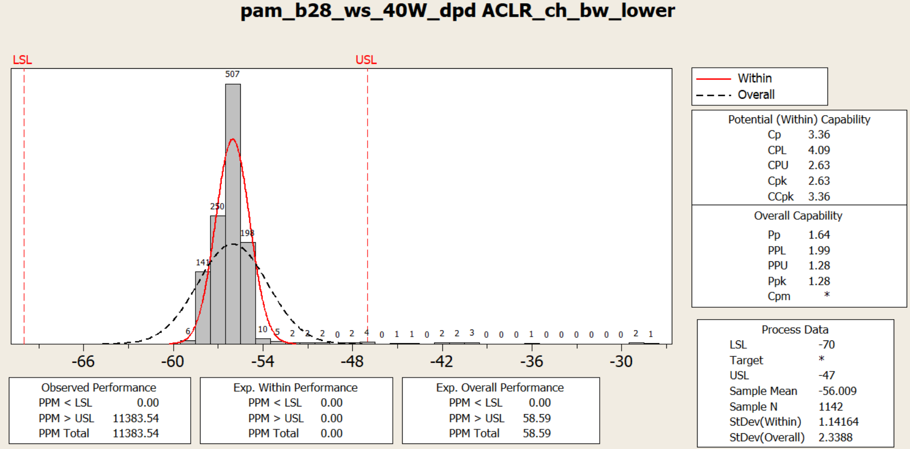

**Process Capability Analysis Report**

**Process Name:** pam_b28_ws_40W_dpd ACLR_ch_bw_lower **Date:** [Insert Date] **Prepared By:** [Insert Name]

**1. Overview**

This report presents the process capability analysis of the characteristic **"pam_b28_ws_40W_dpd ACLR_ch_bw_lower"** to determine how well the process meets its specification limits. The analysis includes a histogram of measured values, process capability indices, and performance metrics.

**2. Specification Limits**

* **Lower Specification Limit (LSL):** -70
* **Upper Specification Limit (USL):** -47
* **Target Value:** Not specified

These limits define the acceptable range within which the process output should fall to be considered compliant.

**3. Statistical Summary**

* **Sample Mean:** -56.009
* **Sample Size (N):** 1142
* **Standard Deviation (Within):** 1.14164
* **Standard Deviation (Overall):** 2.3388

The sample mean indicates that the process output is centered around **-56.009**, well within the specification limits, but long-term variation is significantly higher than short-term variation.

**4. Process Capability Indices**

The process capability indices measure how well the process fits within the specified limits.

**4.1 Potential (Within) Capability**

* **Cp:** 3.36 (Process potential capability)
* **CPL:** 4.09 (Lower process capability index)
* **CPU:** 2.63 (Upper process capability index)
* **Cpk:** 2.63 (Minimum of CPL and CPU)
* **CCpk:** 3.36 (Corrected Cpk)

**4.2 Overall Capability**

* **Pp:** 1.64 (Overall process capability)
* **PPL:** 1.99 (Lower overall process capability)
* **PPU:** 1.28 (Upper overall process capability)
* **Ppk:** 1.28 (Overall capability accounting for both centering and variation)
* **Cpm:** Not provided

**5. Performance Analysis**

**5.1 Observed Performance**

* **PPM < LSL:** 0.00 (No parts below the lower limit)
* **PPM > USL:** 11383.54 (Parts exceeding the upper specification limit)
* **PPM Total:** 11383.54 (Total out-of-spec parts)

**5.2 Expected Performance**

* **Expected Within Performance:**
  + **PPM < LSL:** 0.00
  + **PPM > USL:** 0.00
  + **PPM Total:** 0.00
* **Expected Overall Performance:**
  + **PPM < LSL:** 0.00
  + **PPM > USL:** 58.59
  + **PPM Total:** 58.59

**6. Interpretation & Conclusion**

1. **Process Capability is Good in the Short-Term, but Not in the Long-Term:**
   * The **Cp (3.36)** and **Cpk (2.63)** values indicate a capable process **if short-term variation is considered**.
   * The **Ppk (1.28)** confirms that long-term variation is **causing a much lower capability score**.
2. **High Number of Out-of-Spec Units Observed:**
   * **Observed PPM > USL is 11383.54**, indicating **too many defective parts**.
   * **Expected PPM > USL is 58.59**, showing that ideally, the process should have very few defects.
3. **Increased Long-Term Variation Needs Correction:**
   * The **large difference between Within and Overall Standard Deviations (1.14164 vs. 2.3388)** suggests **drift or uncontrolled variation over time**.
   * This is likely leading to the high observed PPM count.
4. **Process Centering Needs Attention:**
   * The **CPU (2.63) and PPU (1.28)** indicate that **the process is skewed towards the upper specification limit (USL)**.
   * The process may need **adjustments in centering** to bring it **closer to the middle of LSL and USL**.

**7. Final Recommendation**

❌ **Immediate Action Required: The process is not stable in the long term, and a large percentage of units exceed the upper specification limit.**

🔹 **Urgent Corrective Measures:**

* Identify and eliminate the root cause of **long-term process variation (higher overall standard deviation)**.
* Tighten **quality control processes** to reduce defects.
* Consider shifting the **process mean slightly lower** to balance **Cpk and Ppk values**.

🔹 **Ongoing Monitoring & Adjustments Needed:**

* Implement **real-time process monitoring** to detect variation shifts.
* Investigate **possible process drift** causing increasing long-term variation.

**Overall Verdict: ⚠️ The process shows good short-term capability but severe long-term instability. Immediate corrective actions are necessary to reduce defects and improve overall capability. 🚨**

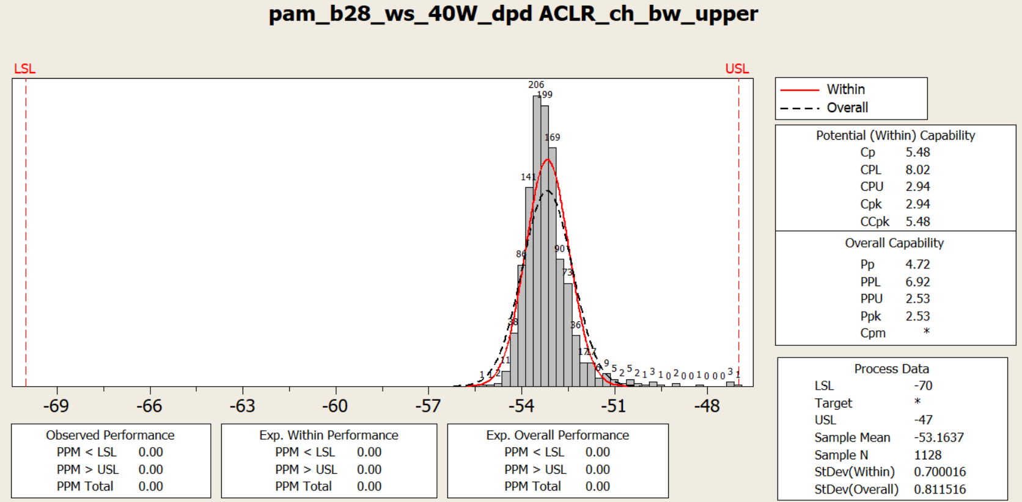

**Process Capability Analysis Report**

**Process Name:** pam_b28_ws_40W_dpd ACLR_ch_bw_upper **Date:** [Insert Date] **Prepared By:** [Insert Name]

**1. Overview**

This report presents the process capability analysis of the characteristic **"pam_b28_ws_40W_dpd ACLR_ch_bw_upper"** to determine how well the process meets its specification limits. The analysis includes a histogram of measured values, process capability indices, and performance metrics.

**2. Specification Limits**

* **Lower Specification Limit (LSL):** -70
* **Upper Specification Limit (USL):** -47
* **Target Value:** Not specified

These limits define the acceptable range within which the process output should fall to be considered compliant.

**3. Statistical Summary**

* **Sample Mean:** -53.1637
* **Sample Size (N):** 1128
* **Standard Deviation (Within):** 0.700016
* **Standard Deviation (Overall):** 0.811516

The sample mean indicates that the process output is centered around **-53.1637**, well within the specification limits.

**4. Process Capability Indices**

The process capability indices measure how well the process fits within the specified limits.

**4.1 Potential (Within) Capability**

* **Cp:** 5.48 (Process potential capability)
* **CPL:** 8.02 (Lower process capability index)
* **CPU:** 2.94 (Upper process capability index)
* **Cpk:** 2.94 (Minimum of CPL and CPU)
* **CCpk:** 5.48 (Corrected Cpk)

**4.2 Overall Capability**

* **Pp:** 4.72 (Overall process capability)
* **PPL:** 6.92 (Lower overall process capability)
* **PPU:** 2.53 (Upper overall process capability)
* **Ppk:** 2.53 (Overall capability accounting for both centering and variation)
* **Cpm:** Not provided

**5. Performance Analysis**

**5.1 Observed Performance**

* **PPM < LSL:** 0.00 (No parts below the lower limit)
* **PPM > USL:** 0.00 (No parts above the upper limit)
* **PPM Total:** 0.00 (No defective parts observed)

**5.2 Expected Performance**

* **Expected Within Performance:**
  + **PPM < LSL:** 0.00
  + **PPM > USL:** 0.00
  + **PPM Total:** 0.00
* **Expected Overall Performance:**
  + **PPM < LSL:** 0.00
  + **PPM > USL:** 0.00
  + **PPM Total:** 0.00

**6. Interpretation & Conclusion**

1. **Highly Capable Process:**
   * The **Cp (5.48)** and **Cpk (2.94)** values indicate that the process has significantly smaller variation compared to the specification range.
   * The **Ppk (2.53)** confirms that the process maintains a high level of capability in the long term.
2. **Zero Defects Observed:**
   * Since **PPM Total = 0.00**, no defective parts were observed, confirming excellent process performance.
3. **Stable Process:**
   * The difference between **Within Standard Deviation (0.700016)** and **Overall Standard Deviation (0.811516)** is minimal, indicating that the process remains stable over time with very little drift.

**7. Final Recommendation**

* No immediate corrective actions are required as the process is highly capable, stable, and producing results well within specifications.
* Regular monitoring should continue to ensure that the process remains within specifications.
* If a target value is defined in the future, a **Cpm index** can be calculated to further evaluate process centering.

**Overall Verdict:** ✅ **The process is highly stable, well-controlled, and fully compliant with specifications. No adjustments are needed.**